# Task 11.2.1

db.restaurant.find({'grades':{$elemMatch:{'score':{$gt:50}}}},{'cuisine':1, 'name':1, '_id':0}});

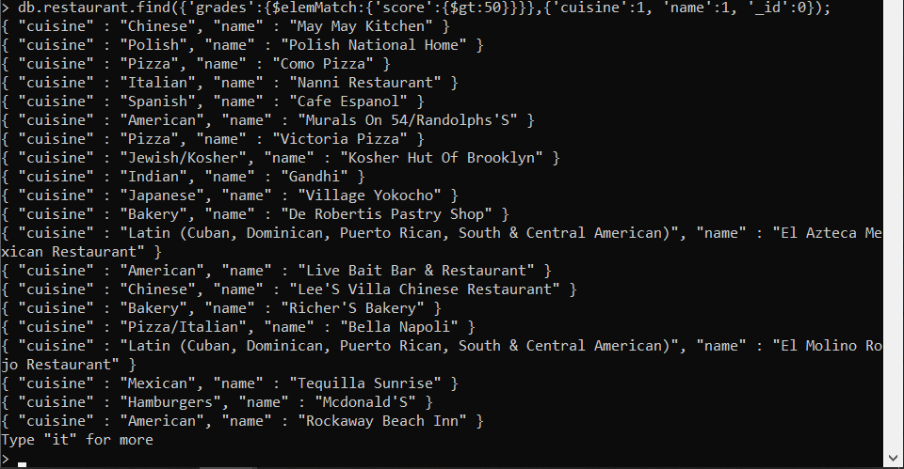

db.restaurant.find({'grades':{$elemMatch:{'score':{$gt:50}}}},{'cuisine':1, 'name':1, '_id':0}}).count();

